First, we go to the tomcat server page: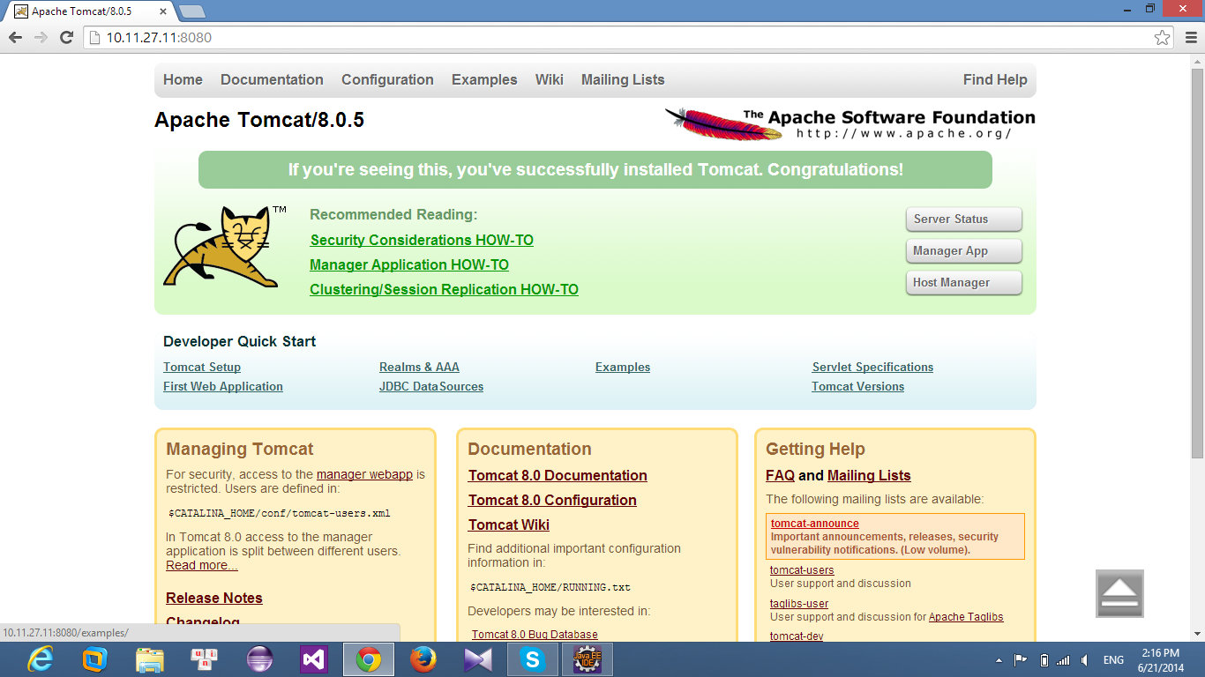

Click Manager App after input Username and Password to on site management application

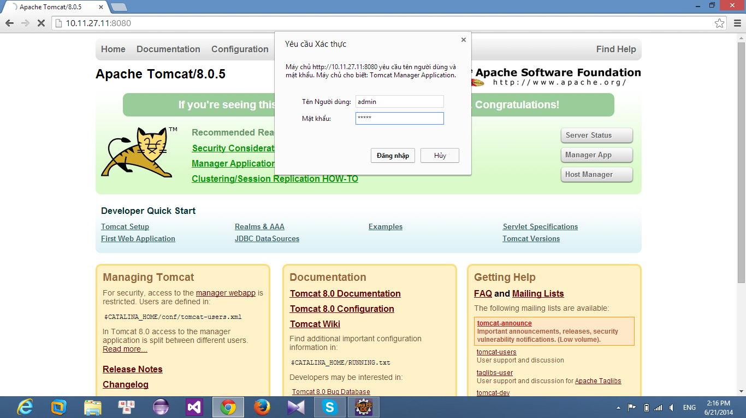

Click Choose File and choose file to deploy and click Deloyer to Deploy product to server.

